45

Shared Responsibility Worksheet for the
Program Leader and Principal
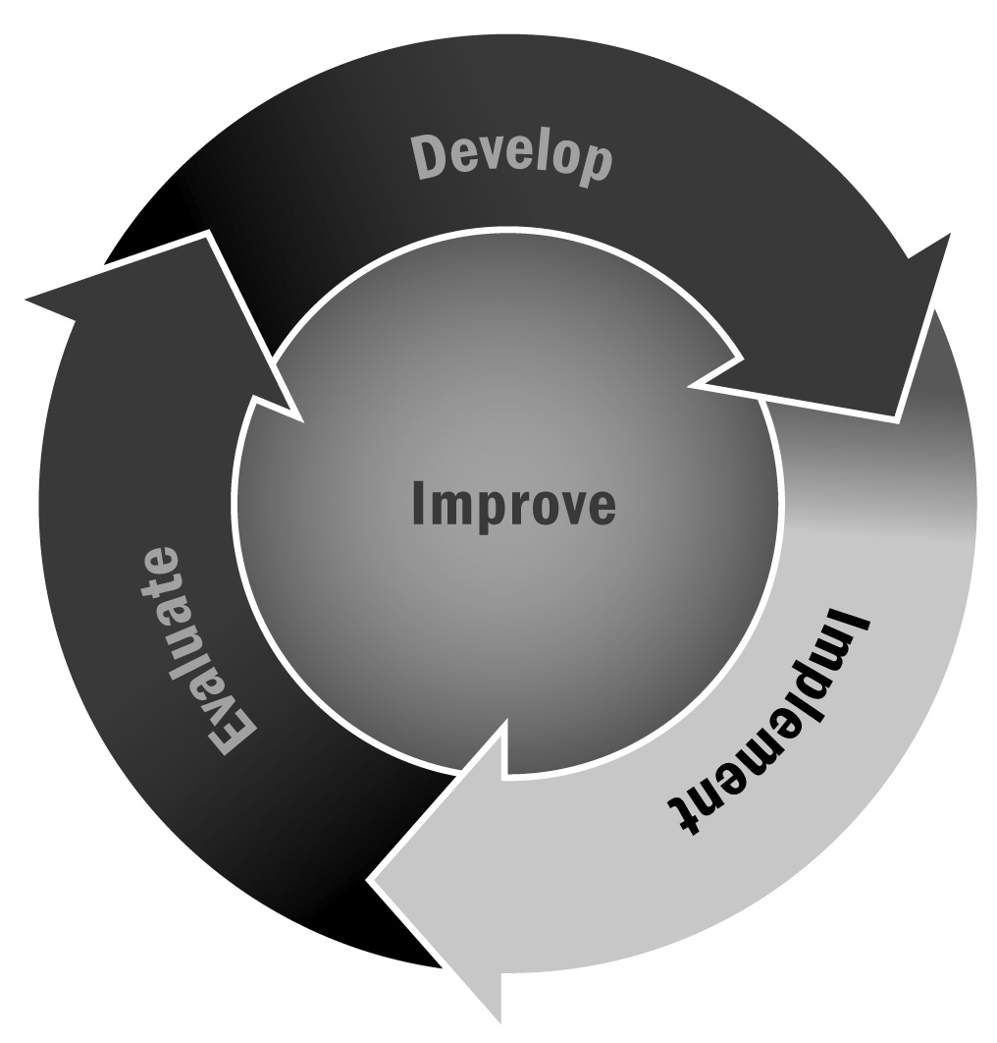
In Chapter 3, you learned that developing a positive relationship with the principal of the school or schools you work with is important. Setting up a meeting with the principal to discuss specific tasks and who is responsible for each will go a long way toward creating a partnership with the school.
Directions: The principal and program or site leader should complete this worksheet together. Review the tasks in the left column. Add any additional tasks that may be needed. Then, for each task, indicate who will be responsible—the principal or the program or site leader—or whether it will be a shared responsibility. If a responsibility will be shared, decide how it will be shared.

Task | Responsibility of Program or Site Leader | Responsibility of Principal | Shared Responsibility (Indicate How)
Secure space for afterschool activities.
Inform school day teachers that their classrooms will be used.
Provide supplies and materials for program.
Handle discipline issues that arise in program.
Communicate with families about the content of program.
Recruit youth for program.
Decide on the type of activities to be offered.
Hire and supervise program staff members.
Register participants for program.
Define the program staff’s training needs.
Other

